**USING RAPTOR – CALCULATE FIBONACCI SERIES**

**R.NIVEDITHA**

**192110054**

**FLOWCHART**

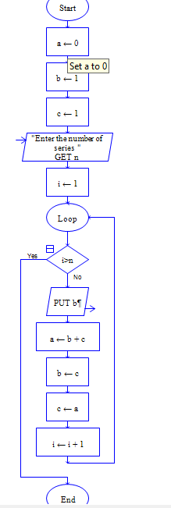

**OUTPUT**

INPUT IS 9

